
Copper City Softball Little League
All Star Policies and Procedures

1.1 Players Intent to Participate
• League Director formulates list of all eligible players. All players are automatically nominated unless prohibited by LL rules.
• Player Agents will review forms with database to ensure all eligible players are listed.
• To be completed by end of May.

1.2 Player Selection Process:
a. Softball 9/12 Player Selection by vote:
• Eligibility:
- 11/12 Softball. All players who meet the Little League requirements for 11/12 Majors, are placed on the All-Star ballot.
- 9/10 Softball. All players who meet the Little League requirements for 9/10 Minors, are placed on the All-Star ballot.
- Players are eligible for the All-Star ballot in the division in which they play during the regular season.
• Voting:
- All 11/12 softball, and 9/10 Softball Managers vote for up to 20 players for their respective leagues.
- The voting process will be administered and overseen by President, VP, Player Agent and/or Division Director.

• The top 12 in total votes automatically make the team.
• If there is a tie for the 12th spot, the Manager gets to choose the player or elect to take up to 13 players. An alternate list will be created between 5-10 players.
• Once players are selected, a parent or guardian will be given “Post-Season Tournament Parental Consent Form” (the “Commitment Form”).
- Once received, the parent/guardian has 24 hours to review, sign and return the form to the Little League President via email (coppercitysoftball@gmail.com). If not received within 24 hours, then their player will no longer be eligible for the team, and placement on team will be offered to the next alternate on the list based on vote count.
- If a player chooses not to play, then the next alternate player based on vote count will be asked to play.

b. Other All-Star Teams -- Player Selection by Manager:
• If CCSLL so chooses, a 2nd all-star team can be formed and player selection will be by Manager.

1.3 Manager Selection Process:
• Any manager or rostered coach in good standing from each league is eligible to be manager of an All-Star team for their respective age league level.
• Exception is only Major Division Managers are eligible to manage the Little League (11-12’s) All-Star team.
• Interested individuals must submit their names to League Director.
• League Director presents names to managers in the division, at a meeting of managers from the division. Each candidate will be allowed 2 minutes to speak. After all candidates speak, the managers will vote by show of hands for each candidate. If a manager is unable to attend, a proxy vote will be allowed. Proxy vote will be read to all by League Director. No one will be allowed to abstain from voting, and a manager must vote for himself/herself if on ballot.
• The candidate with the most votes will be named manager.
• If there are more than 2 candidates and there is a tie for the most votes, the ones not tied are eliminated. A re-vote will take place for only those that are tied.
• If there are only 2 candidates and the vote ends in a tie, then the League Director, President, and VP will each cast a ballot on paper. Those ballots will be read out loud to all present without divulging who voted for whom. If any of those 3 are managers in that league, then player agent will vote.
• All selected managers must have CCSLL board approval.

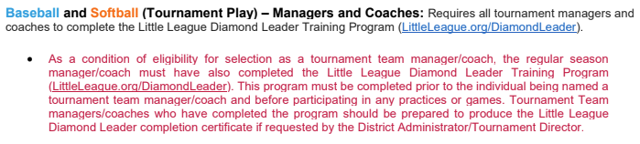
1.4 Coach(es) Selection Process:
• All Star assistant coaches are selected by the Manager.

